Welcome to Python
Alright everybody, you’ve installed Python on your computer, and it’s about time to learn how to use it. Fortunately, it was designed to be one of the easier languages to learn. So let’s start with the IDLE.
IDLE stands for Integrated DeveLoping Environment (usually just IDE, but somebody thought it’d be funny if they named it after a member of monty python).
So to open it, just search for python and open the IDLE for Python 3. It looks like this when press the windows key and type python (and yeah, I changed the wording):
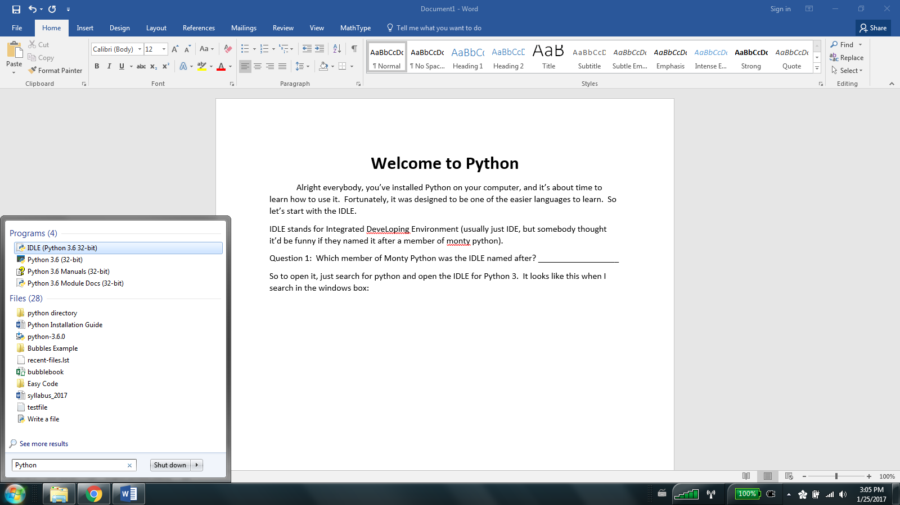

Click that IDLE program and it should open the IDLE for Python, which in turn looks something like this:
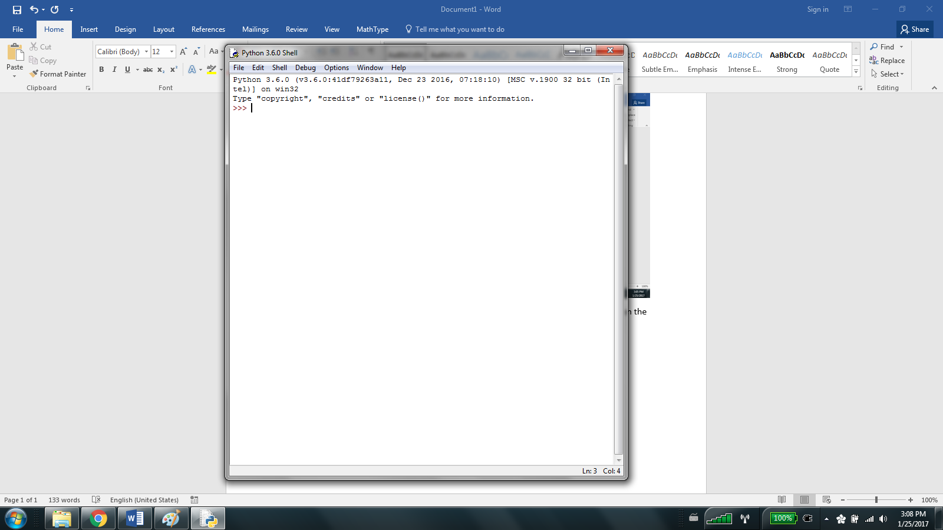
And now we’re rolling! From here we can test simple commands, and create new programs, and even run them! The three right arrows indicate the interpreter prompt, and we can start testing out some pretty simple things here.
Try typing print(“Goodbye World”) and hitting return. What happened? It should have printed a somewhat depressing twist on the most common first programming exercise! This is what should’ve happened:
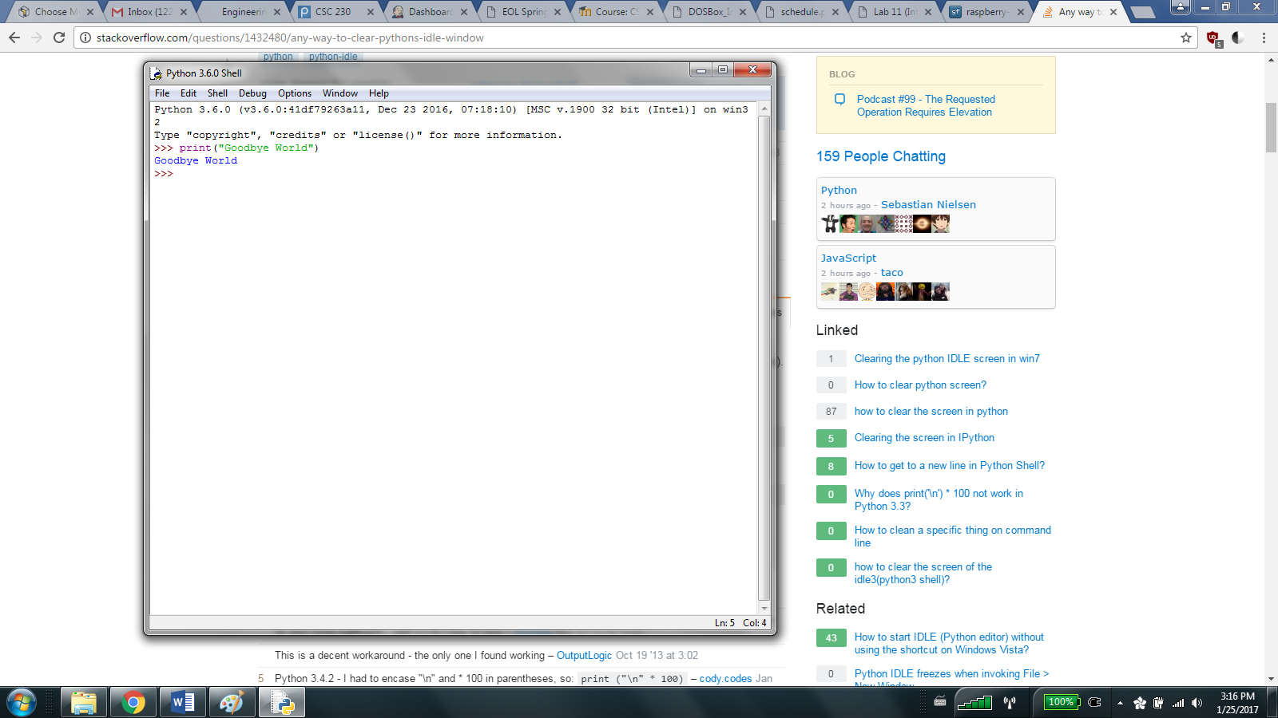

If not… then keep trying? We’re gonna try one more thing before we move onto really learning how to program in python.

Go to the top of the shell, click File, and then click New File, and a new window (should) open. Congratulations! You’ve created your first program! Hopefully your screen looks like this now:
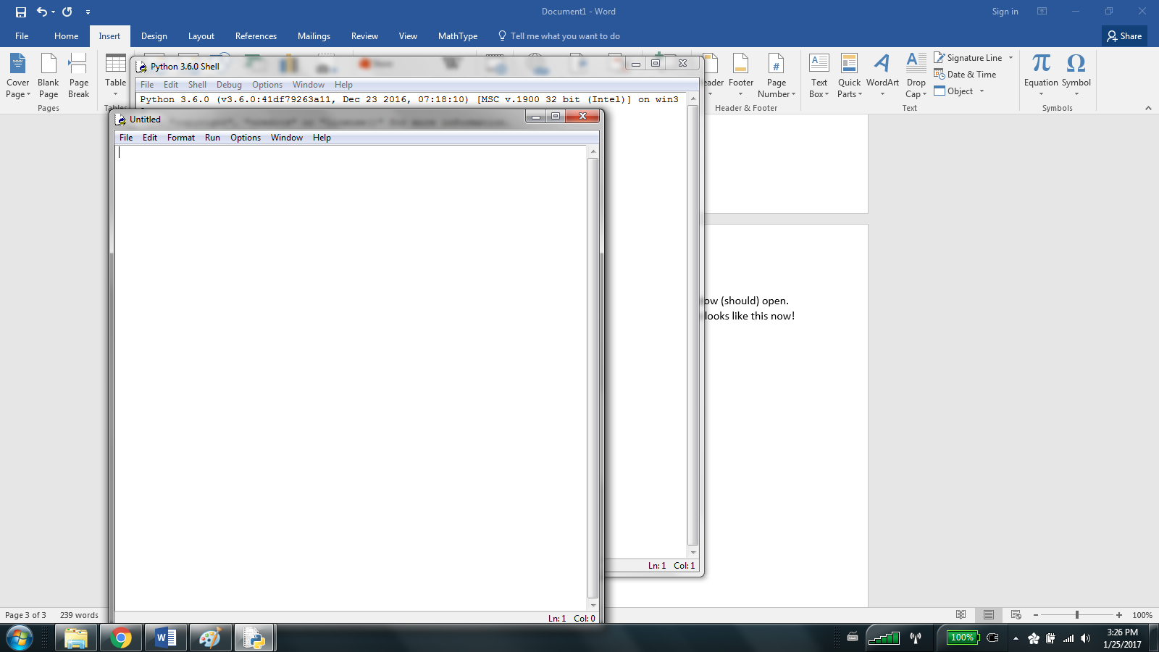
Now, type print(“Goodbye World”) and save the file as like, first python ever or something. I recommend you make a folder to corral all these files, but it’s up to you. I like finding things personally, which is why I made a folder called TE 205 Python Files in my projects directory (although my documents would’ve probably been better). Now if you hit run, and click run module (F5 on my compy) then it should restart the IDLE and print goodbye world! Fantastic! You are certified to open the IDLE, to create a program, to save it, to look at pictures, and to run a program from the IDLE.

